INTRODUCTION:
All the real structures are actually infinite degree of freedom systems. However, for the purpose of studying their dynamic behaviour we can idealize them into single or multi degree of freedom systems. If mass of the structure can be lumped at different locations in the structure then the dynamic behaviour consists of same number of modes of vibration. Such structure is called a multi degree of freedom system. Typically in a multi-storey building, masses of different elements can be lumped at centre of mass at each slab level.
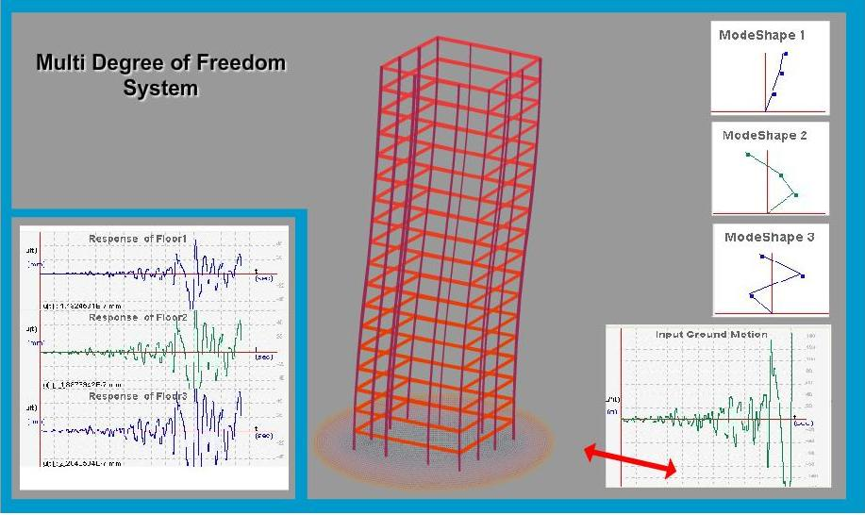
THEORY:

Equation of motion of multi degree of freedom system in matrix form
where,
[m] = Mass Matrix.
[k] = Stiffness Matrix.
[c] = Damping Matrix
{I} = Unit Vector
The physical coordinates {x} may be related with normal or principal coordinates {q} as,
{x} = [φ]{q}
where,[φ] = Modal Matrix.
Time Derivate of {x} are
{x'} = [φ]{q'}
{x''} = [φ]{q''}
Substituting the time derivatives in equation of motion and pre multiplying by results.
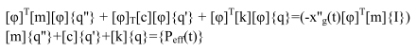
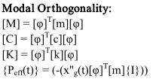
[m],[c], and [K] are the diagonlized modal mass matrix, modal damping matrix and stiffness matrix and is the effective modal force vector.
Finally, by using numerical methods like Newark’s linear acceleration method, Newark’s average acceleration method, central difference method etc. We will find the response each floor of given structure.

OBJECTIVE:

To find out natural frequencies and natural mode shapes of multidegree of freedom system. To find out response of each floor to a given ground motion.

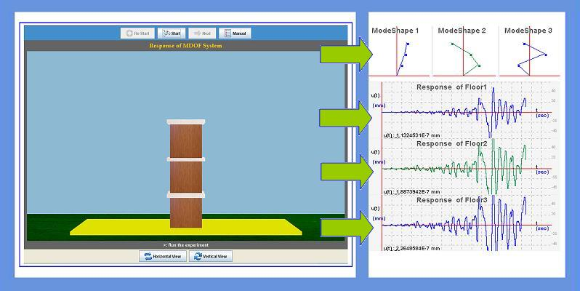
MANUAL:
Observation 1: Finding natural frequencies and mode shapes
1. Take n storey structure.
2. Input mass and stiffness of each storey
3. Run the experiment. User can see eigen values (natural frequencies) and eigen vectors (mode shapes).
4. Use may note the eigen vectors and check for modal orthogonality.
Observation 2: Find the response of the structure to given ground motion.
5. Take n storey structure.
6. Input mass and stiffness of each storey.
7. Select ground motion and also damping.
8. Run the experiment. User can find the response of the each floor level on the screen. User can also find the response of each mode.

PART - 2
ANIMATION STEPS
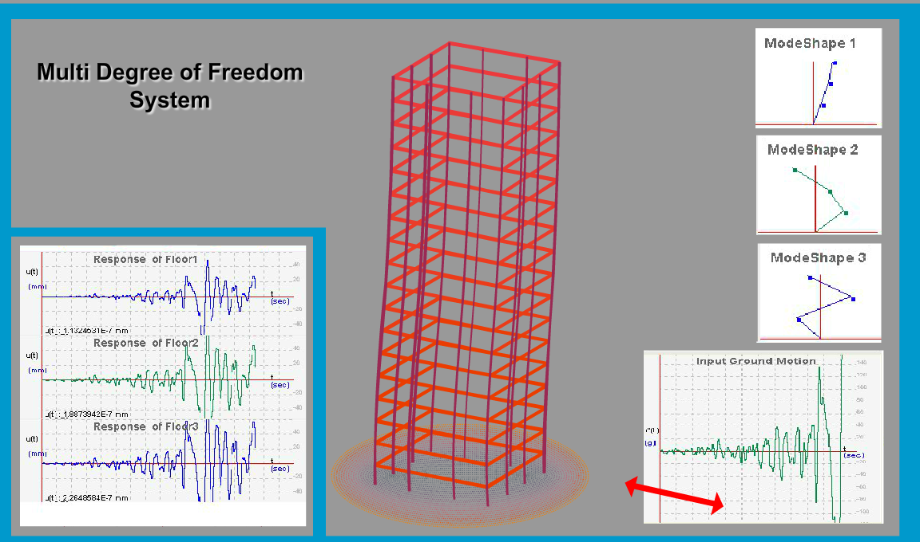

PART – 3
VIRTUAL LAB FRAME

